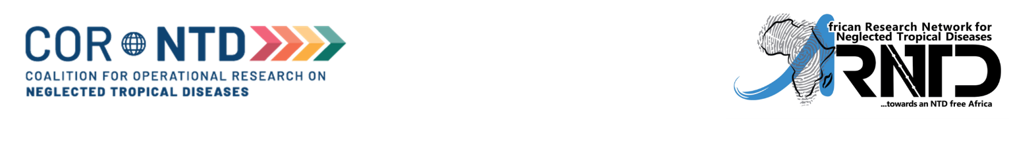

Small Grants Program: Checklist for Applicants

* All applicants are encouraged to carefully read through the detailed eligibility criteria provided in the Reviewers Guide and the Call for applications
* Applicants may utilize this checklist as a quick reference guide to ensure that the application(s) submitted is eligible, and that all responses/documentation have been submitted.

|  |  |
| --- | --- |
| **Check** | **Guide/Requirements for Eligible Applications** |
|  | Reviewers Guide has been read in full |
|  | Chosen grant category is justified by your current academic background and research experience. |
|  | Disease of interest is focused on any or a combination of the five preventive chemotherapy (PC)  NTDs (i.e. Lymphatic filariasis, Onchocerciasis, Soil transmitted helminthiasis, Schistosomiasis and  Trachoma) |
|  | If non-PC NTD, the disease of interest shows a contribution to efforts to help control one or more of the PC NTDs |
|  | Project primarily focused on improving access to interventions for vulnerable populations such as nomads, groups in conflict zones, and rural/hard-to-reach areas, refugees and the disabled are also required to focus on the PC-NTDs. However not all projects focused on the PC NTDs are required to target vulnerable populations |
|  | Proposal satisfies qualifying criteria for Operational and Implementation Research |
|  | Word limits for answers to all questions have been strictly adhered to |
|  | Application has evidence of engagement with National NTD programs |
|  | Application indicates approach for transfer of knowledge and/or dissemination of results |
|  | For mid-career/senior researcher applicants, proof of matching funds to which SGP funds will augment is provided |
|  | Budget has been prepared in line with allowable funding rules for SGP as specified in Budgeting  Instructions |
|  | Budget has been uploaded or emailed to the ARNTD Secretariat |